Paulo Intermediate School 75
Proceed as if limits to our own ability do not exist
455 Huguenot Avenue
Staten Island, NY 10312
Tel: 718.701.6343
Fax: 718.701.6351

Ken Zapata
Principal

N
October, 2022

Dear Students, Parents and Members of the Paulo Faculty:

We are pleased to announce that we are commencing our 22nd Annual Holiday Toy Drive to benefit Blythedale Children’s Hospital.

Blythedale Children's Hospital is dedicated to improving the quality of life for children with complex medical and rehabilitative needs. For more than 100 years, Blythedale has been a leader in developing innovative, multi-disciplinary inpatient and ambulatory programs, as well as a community resource for children with a variety of medical concerns.

Founded more than 100 years ago, Blythedale Children's Hospital is a 92-bed non-profit children's hospital serving youngsters from birth through age 19 without regard to sex, financial ability, religion, or race. Through its inpatient and day hospital programs, it treats more than 300 children daily, making it one of the largest children's services in the State. It is also the only hospital in New York State with its own separate public school on site, uniquely designated to serve the special needs of its children.

We began this tradition in December of 2001. Each year, the number of toys donated by our school has increased significantly. We coordinate this event with WCBS Radio Morning Show (101.1 FM) and with the hospital. We will be delivering the items on Thursday, December 15th so that the items can be distributed to the Blythedale families.

Blythedale has specifically asked for help with the needs of infants and toddlers. This is due to the overwhelming number of children of that age group in the hospital. We are limiting our collection to the items posted on the back of this letter.

Students may drop of their donations each day to Mr. Herrmann’s office in Room 339. Donations will be logged for service credits and for credits toward 8th Grade Philanthropy Award applications. We will begin our collection on November 1, 2022. Students will be allowed to do this during their advisory class.

Please join us in this wonderful tradition. If you have any questions regarding this effort, please feel free to contact Mr. Herrmann at (718) 701-6343, extension 3391.

Please see the back of this letter for a list of supplies that we are collecting for Blythedale

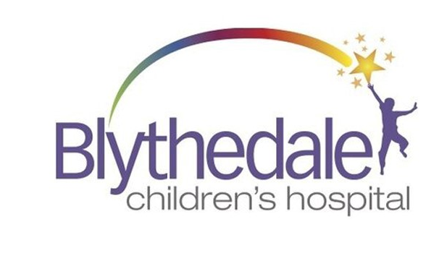

Due to safety & infection control reasons, these are our donation guidelines:
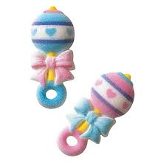
- New, unwrapped items only, including clothing
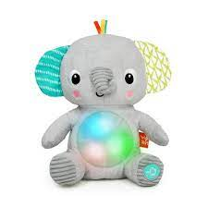
- No gently-used items
- No stuffed animals
- No toys containing latex
- No products containing nuts

2022 Wish List: Infant & Toddler
There are many baby items and toys available, but these are the items that our babies need the most…
and we can use them in great quantities!
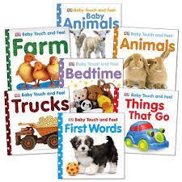
- Rattles
- Light-up toys
- Musical toys
- Board books (both English & Spanish)
- Sound machines
- “My 1st” gear (items for holidays/milestones)
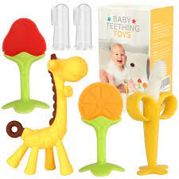
- Crib mirrors
- Swaddle blankets
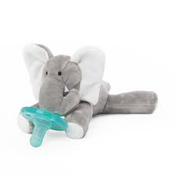
- Teething toys
- WubbaNub pacifiers
- Bath toys
- Gift cards
